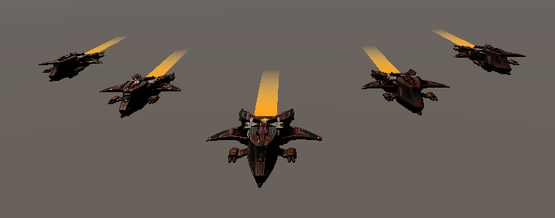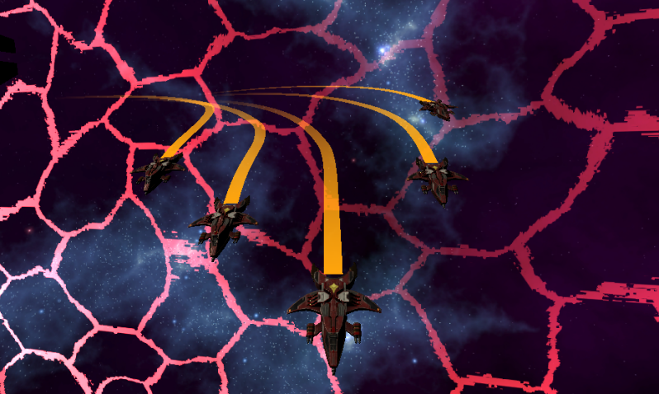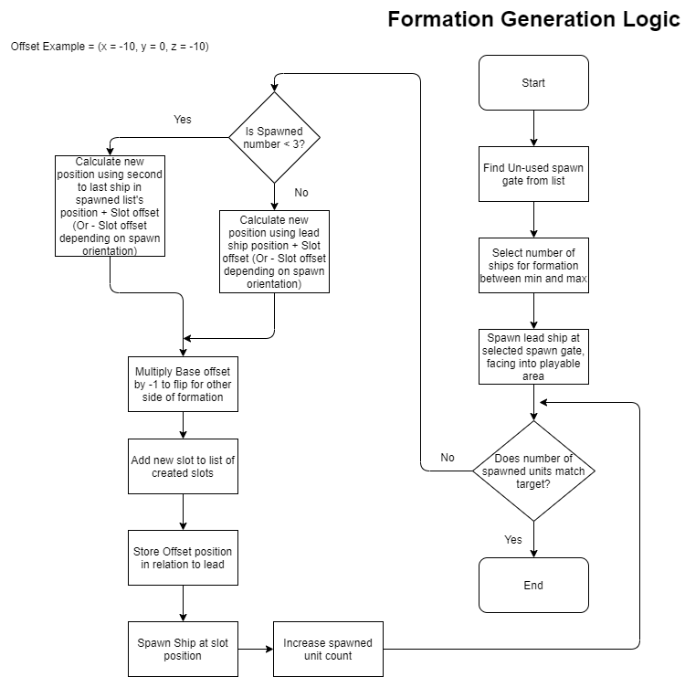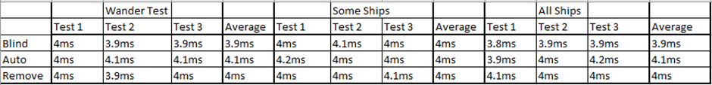

# Introduction

* The papers aim was to take a range of existing methods for formation movement within game AI and test their effectiveness when applied to aerial movement.
* Research was conducted to explore what methods were available, how they behaved and how they could be implemented to aerial movement.
* Three behaviours were selected based on their potential to yield different behaviours and built into an aerial combat game.
* These implementations were then tested against a range of factors to determine their effectiveness.

# Testing

## Performance

* Measure the average time to update a frame under specific situations.
* Measurements taken using Unity’s built-in Profiler system.
* Situations were selected based on which behaviours the formation is likely to be doing most often or are most logic intensive.
* Selected situations were; general movement, turning to avoid an obstacle which affects all ships and turning to avoid an obstacle which affects some ships.

## Experience

* Group of testers were shown videos of each implementation moving in the previously mentioned situations and given a build per implementation to play through for 10 minutes.
* After which testers completed a questionnaire asking them to rank the implementations with specific criteria such as visual appeal or realism.

# Method

## “Blind”

* Found in: Mars, C. Chanut, J. (2015)
* All units follow a designated “lead” unit
* Any turns or actions only impact this “lead” unit, with other units moving in relation to the lead at all times
* Leads to behaviour where units have no independent actions and rigidly stay in formation

## “Autonomous”

* Found in: Mars, C. Chanut, J. (2015)
* Formation still contains a “lead” unit; however units are given some independent ability.
* Unless an obstacle is present, units will still follow the “lead” unit. If an obstacle is present units will break from the formation to avoid unless the obstacle affects all the ships within the formation.
* Leads to behaviour where units are able to break formation to avoid obstacles which do not affect the entire formation

## “Remove the Leader”

* Found in: Millington, I. and Funge, J.D. (2009)
* Similar to “Autonomous”, only “lead” unit is treated as a regular unit, with the formation following an invisible “leader” rather than a physical unit.
* Leads to similar behaviour as Autonomous however lead unit is capable of avoiding obstacles without affecting other units.

# Results

## Performance Testing

* Small drops in performance to some implementations, however all changes were small enough to be unnoticeable in testing and gameplay.

## Experience Testing

* Testers enjoyed the individuality which came from “Remove the Leader” overall and disliked units from “Autonomous” were only partially independent.

## Overall

* Due to the lack of changes from performance testing, “Remove the Leader” was considered most effective and “Autonomous” was considered least effective due to the experience testing results.

# References

* Mars, C. Chanut, J. (2015) ‘Hierachial Architecture for Group Navigation Behaviours’. In Rabin, S. (ed.) *Game AI Pro 2*. Boca Raton: CRC Press, Taylor & Francis Group. p.209- 222
* Millington, I. and Funge, J.D. (2009) *Artificial intelligence for games*. 2nd edn. San Francisco, Calif.; Oxford: Morgan Kaufmann; Elsevier Science. p.148- 149

Daniel Bailey, S193338, S193338@uos.ac.uk

**A comparison of formation movement techniques in aerial flight**